Image | Element-Cultural Universal | Example | URL
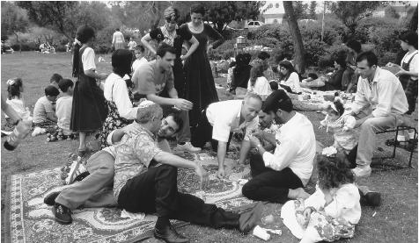  Celebrating Passover with a picnic | Belief System | Religion | http://www.everyculture.com/Ge-It/Israel.html
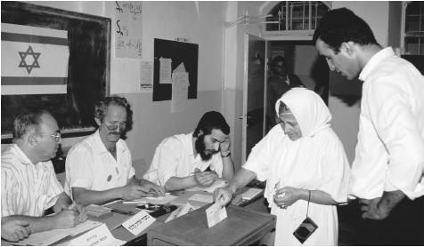  People voting in an election | Politics | Decision making | http://www.everyculture.com/Ge-It/Israel.html
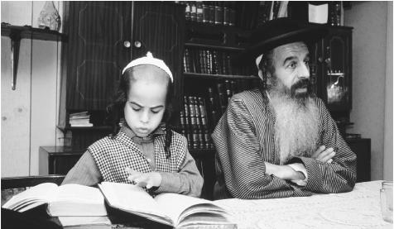  Torah scribe working with his son | Belief System | Religion | http://www.everyculture.com/Ge-It/Israel.html
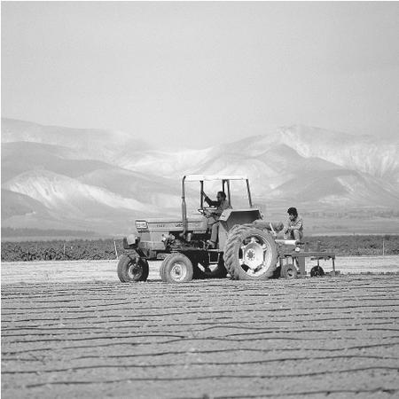  Preparing the land for winter crops | Economics | Resources | http://www.everyculture.com/Ge-It/Israel.html
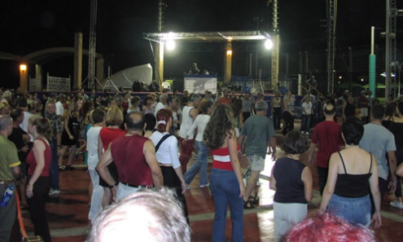  Folk dancing | Aesthetics | Dance | http://www.ifcj.org/site/PageNavigator/eng/inside/israel_in_pictures
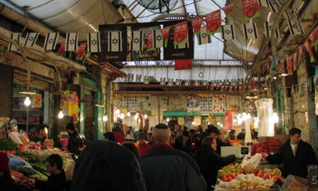  Market in Jerusalem | Economics | Resources | http://www.ifcj.org/site/PageNavigator/eng/inside/israel_in_pictures
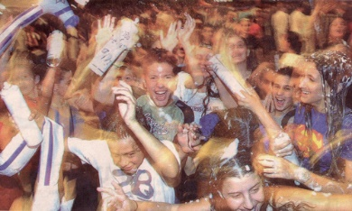  Israel’s 56th independence Day | Social Aspects | Customs | http://www.ifcj.org/site/PageNavigator/eng/inside/israel_in_pictures
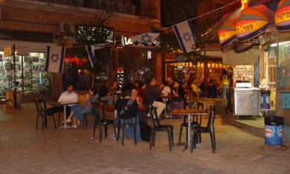  Saturday night in Jerusalem | Social Aspects | Leisure Activities | http://www.ifcj.org/site/PageNavigator/eng/inside/israel_in_pictures
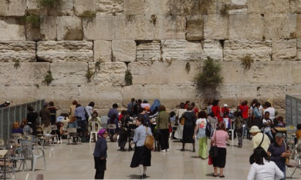  Women’s section of the Western Wall | Social Aspects | Customs | http://www.ifcj.org/site/PageNavigator/eng/inside/israel_in_pictures
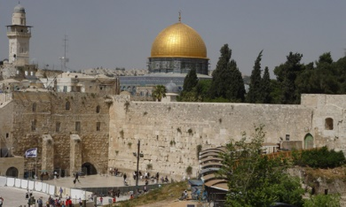  Western Wall | Belief System | Ritual | http://www.ifcj.org/site/PageNavigator/eng/inside/israel_in_pictures
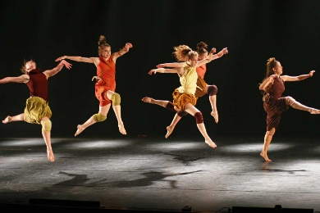  Israel folk dancing | Aesthetics | Dance | http://www.israel-travel-secrets.com/israel-culture.html
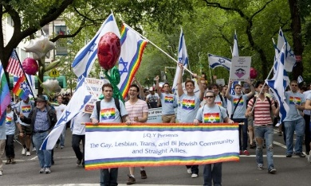  Israel grants citizenship to same-sex spouses | Politics | Decision-making | http://www.shalomlife.com/news/25157/israel-grants-citizenship-to-same-sex-spouses-of-jews/
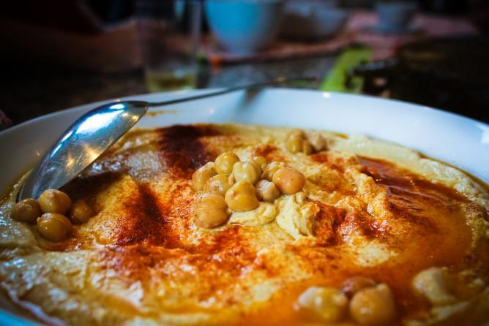  hummus | Social Aspects | Custom | http://theculturetrip.com/middle-east/israel/articles/tel-aviv-s-10-best-cultural-restaurants-great-middle-eastern-eats/
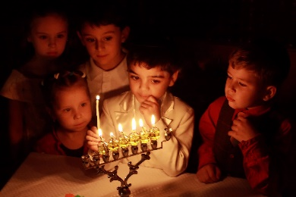  Hanukkah | Belief System | Religion | http://www.blog.standforisrael.org/?attachment_id=41198
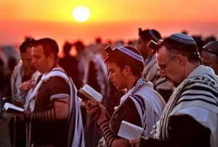  Observance of Yom Kippur | Belief System | Religion | http://blog.godreports.com/2013/04/date-setting-a-curious-slip-and-yom-kippur/

